Savitribai Phule Pune University



*A Project Report*

*On*

**Design of test rig using tune mass damper**

Submitted by

**Mr. Somnath Sapkal 72025878C**

**Mr. Tejas Khatpe 72025740K**

**Mr. Sanat Sarang 72025879M**

**Mr. Gopal Chavan 72025609H**

Under the guidance of

**Prof. Suhas S. Jadhav Sir**



Department of Mechanical Engineering

Modern Education Society’s

College Engineering, Pune-411 001

[2021-22]

**MODERN EDUCATION SOCIETY’S**

College of Engineering, Pune 01



**C E R T I F I C A T E**

This is to certify that the project work entitled **“Design of test rig using tune mass damper”** is a bonafide work carried out by **Mr. Somnath Sapkal** , **Mr. Tejas Khatpe , Mr. Sanat Sarang , Mr. Gopal Chavan** in partial fulfilment for the award of Bachelor Of Engineering in Mechanical Engineering of the Savitribai Phule Pune University during the year 2022-23..It is certifies that all the corrections/suggestions indicated for internal assessment have been incorporated in the report deposited in the department library. The project report has been approved as it satisfies the academic requirements in respect of project work prescribed for the Bachelor of Engineering degree.

Prof. Suhas S. Jadhav Dr. V. N. CHOUGULE

Guide Head of Department

Dept of Mechanical Engineering

Dept of Mechanical Engineering MESCOE Pune-411001

MESCOE Pune-411001

Principal

M.E.S.College of Engineering

Pune-411001

**External Viva**

Name of the Examiner Sign

1.

2.

**ACKNOWLEDGEMENT**

It gives us an immense pleasure to express our gratitude and thanks to all those who helped in the timely completion of the project work phase I.

We have a great pleasure in expressing our deep sense of gratitude and indebtedness to **Prof. Suhas S. Jadhav**, Project Guide for their invaluable guidance, constant supervision and sustained encouragement throughout the tenure in this dissertation work.

We would like to express our thanks to, **Dr.V.N.Chougule**, Head of Department, Department of Mechanical Engineering, Modern Education Society’s College of Engineering Pune for their constant support and encouragement.

We would like to express our thanks to Principal, Modern Education Society’s College of Engineering Pune for permitting us to take up the project work.

We are thankful of our parent and friends for their kind help and support throughout the course.

Somnath Sapkal

Tejas Khatpe

Sanat Sarang

Gopal Chavan

# *ABSTRACT*

An earthquake is a natural phenomenon associated with violent shaking of the ground. They are vibrations of the earth’s surface caused by sudden movements of earth crust mostly due to tectonic movements. Since earthquake forces area unit random in nature and unpredictable, the engineering tools must be sharpened for analysing structures below the action of those force. Tuned mass dampers are well known devices for the passive control of vibrations in buildings subjected to earthquake loadings. Various methods have been proposed for the design of tuned mass damper (TMD) systems. TMD is also known as passive mass damper (PMD) or harmonic absorber. It is a device mounted in structures to reduce the amplitude of mechanical vibrations. Their application can prevent discomfort, damage, or outright structural failure. Application of TMD damper reduces large amount of displacement of the structure. TMD are preferably placed where the structure difference is maximum. The advantage of tune mass damper is that they do not depend on an external power source for their operation. They can respond to small level of excitation. Their properties can be adjusted in the field. They use a comparatively lightweight component to reduce the vibration of a system so that its worstcase vibrations are less intense. The components of TMD include the mass, spring and the damper. Utilizes a secondary mass attached to a main structure through spring and dashpot. Secondary mass system has a natural frequency closed to the primary structure which depends on its mass and stiffness. The excess energy that is built up in the structure can be transferred to a secondary mass and is dissipated by the TMD. By specifying the mass ratio of the secondary mass to the primary body, the optimum frequency ratio between the two masses and the optimum damping ratio of the secondary mass can be obtained. This secondary mass can be made of any material such as concrete or steel, while damping is generally provided by viscous damping devices. Vibration analysis of structure can be done with the help of Tune Mass Damper.

**TABLE OF CONTENTS**

Acknowledgement i

Abstract ii

Content iii

List of figures iv

List of table v

Nomenclature vi

1. **Introduction**................................................................................... .01
   1. Overview of composite materials.......................................... .01
   2. Natural fibres (Reinforcement)............................................. .04
      1. Bamboo fibres..................................................... .04
      2. Bagasse fibres...................................................... .05
   3. Matrix materials.................................................................... .06
      1. Filler materials.................................................... .07
      2. Hardeners............................................................ .07
      3. Resin..................................................................... .08
   4. Problem statement................................................................ .09
   5. Objective.............................................................................. .09
2. **Mechanical properties............................................................... .10**
3. **Literature survey.......................................................................... .13**
4. **Methodology................................................................................. .16**
5. **Progressive chart.......................................................................... .17**
6. **References...................................................................................... .18**

**LIST OF FIGURE**

|  |  |  |
| --- | --- | --- |
| Figure | Description | Page No |
| Figure1.1 | Figure detail |  |
|  |  |  |
|  |  |  |
|  |  |  |

**LIST OF TABLES**

|  |  |  |
| --- | --- | --- |
| Table | Description | Page No |
| Table 1 | Table detail |  |
|  |  |  |
|  |  |  |
|  |  |  |

**CHAPTER 1**

**INTRODUCTION**

**1.1Overview of Composite Materials**

Natural fibres like sisal, banana, jute, oil palm, kenaf, recycled jute and coir have been used as a reinforced composite for advanced applications such as aircraft and aerospace structures and for ordinary applications like consumer goods, furniture, low-cost housing and civil structures. The incorporation of stiff fibres in soft matrices can lead to new materials with outstanding mechanical properties encompassing the advantages of both the fibre and matrix. Fibre-reinforced composites are strong stiff and lightweight materials that consist of strong, stiff, but commonly, brittle fibres encapsulated in a softer, more ductile matrix material.

The natural fibre composites can be very cost effective material especially for building and construction industry (panels, false ceilings, partition boards etc.) packaging, automobile and railway coach interiors and storage devices. This also can be a potential candidate in making of composites, especially for partial replacement of high cost glass fibres for low load bearing applications. However in many instances residues from traditional crops such as rice husk or sugarcane bagasse or from the usual processing operations of timber industries do not meet the requisites of being long fibres. Composite materials can be classified in different ways. A typical classification is presented in Fig1.1.

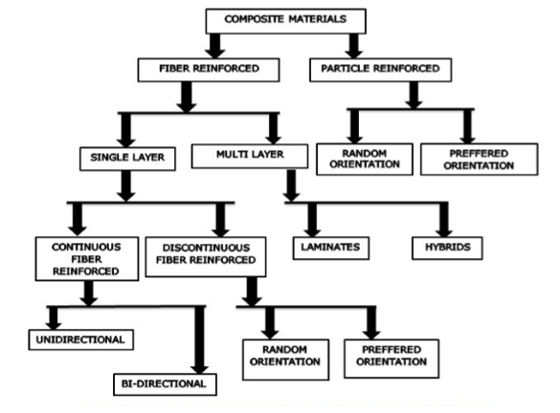

**Fig 1.1 Classifications of Composite Materials**

**1.2Natural Fibres (Reinforcement)**

Natural fibre composites such as flax, hemp, bagasse, jute, ramie, bamboo, coir, and sisal are emerging as a viable alternative to glass fibre composites, particularly in automotive, packaging, and building and are becoming one of the fastest growing additives for thermoplastics. Thus, natural fibres possess high potential for use as outstanding reinforcements in lightweight structures. Natural fibre-reinforced bagasse and bamboo plastic composites have gained more attention because of their low cost, processing advantages, good strength and stiffness.

**1.2.1Bamboo fibre**

Bamboo has found numerous applications in human life for centuries. In recent years however, bamboo has generated interest from researchers as a candidate to replace environmental unfriendly glass as fibre in fibre reinforced composites. This is due to the potential properties of bamboo that has high specific strength and stiffness besides being biodegradable, sustainable and renewable.The high strength of bamboo in fibre direction is due to the longitudinally alignment of its fibre to its body while at the same time this is attributed by its polylamelate wall structure that consists of alternating broad and narrow layers with different fibrillary orientation. Fig. 1.2 shows different forms of bamboo fibre being used as composite reinforcement.

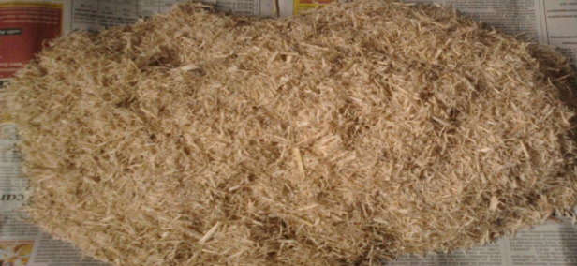

**Fig. 1.3 Bagasse Fibre**

**1.3.3 Resin**

Resin is basically in polymer chemistry & material science is a solid or highly viscous substance, which are typically convertible into polymers. The most widely used resins are polyester resin, vinyl-ester, epoxy resin. Polyester is most commonly used resin, but with limited structural properties. It is not suitable for use when high structural properties are required or when used in extreme temperature conditions. Epoxy resin have high structural properties but are mostly used for metal composites. Vinyl-ester have higher resistance to greater vibrational load.

**Table 1.3 Comparative study of polyester, epoxy, and vinylester resin**

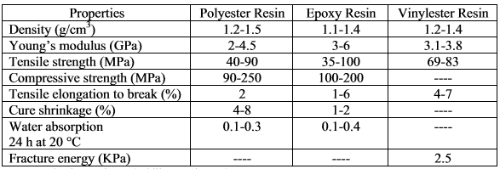

**1.4 PROBLEM STATEMENT**

To find the mechanical characteristics of biocomposites materials by fabricating the natural fibres bamboo and baggase with different percent by weight ratio by using fillers, hardeners & resins with proper proportion.

**1.5 OBJECTIVES**

* To fabricate the bamboo-baggase free oriented reinforced biocomposites.
* To find the mechanical characteristics of the biocomposite material by Tensile test, Impact and Flexural test according to ASTM standards.
* To substitute the natural fibre composite instead of using synthetic fibres.

**CHAPTER 2**

**LITERATURE SURVEY**

**S. A. H. Roslan, et al[1]** Inthis paper, they gave the properties of bamboo reinforced composites from numerous characterization studies of bamboo that are available in the literatures. The review is based on characterization studies on several types of bamboo reinforced composites such as laminated bamboo fibre reinforced composite, randomly oriented bamboo reinforced composite, hybrid fibre reinforced composite, bamboo fibre reinforced bio-composite and bamboo fibre sandwiched structure composite. It can be said that the laminated bamboo composite in general gives higher mechanical properties compare to other structural forms of bamboo composite. Even though bamboo bio-composite in general provides low mechanical properties, the properly design unidirectional bamboo bio-composite can also have high mechanical properties that are as good as the laminated bamboo reinforced composite. While specific tensile properties of laminated bamboo reinforced composite are at par with glass fibre reinforced composite, the mechanical properties of bamboo fibre reinforced composite are comparable to the mechanical properties of the best among natural fibre reinforced composites. The specific tensile properties of laminated bamboo reinforced composite are at par with glass fibre reinforced composite, while the mechanical properties of bamboo fibre reinforced composite are comparable to the mechanical properties of the best among natural fibre reinforced composites such as the kenaf, jute and hemp based composites**.**

**D. Verma, et al.[2]**In this paper theydiscusses the use of bagasse fibre and its current status of research. Many references to the latest work on properties, processing and application have been cited in this review. Reinforcement with natural fibre in composites has recently gained attention due to low cost, low density, acceptable specific properties, ease of separation, enhanced energy recovery, C02 neutrality, biodegradability and recyclable nature. Thousands of tons of different crops are produced but most of their wastes do not have any useful utilization. Agricultural wastes include wheat husk, rice husk and their straw, hemp fibre and shells of various dry fruits. These agricultural wastes can be used to prepare fibre reinforced polymer

**CHAPTER 3**

This chapter shall be based on your own simulation work (Analytical/ Numerical/FEM/CFD)

**CHAPTER 4**

Experimental Validation - This chapter shall be based on your own experimental work

**CHAPTER 5**

**CONCLUSION**

**REFERENCES**

[1] Collier, G. J. and Thome, J. R., Convective boiling and condensation, 3rd ed., Oxford University Press, UK, 1996, pp. 110 – 112.

[2] D. S. and Radermacher, R., Transport properties and surface tension of pure and mixed refrigerants, ASHRAE Trans, 1991, 97 (1), pp. 90 – 98.

[3] Bansal, P. K., Rupasinghe, A. S. and Jain, A. S., An empirical correction for sizing capillary tubes, Int. Journal of Refrigeration, 1996, 19 (8), pp.497 – 505.